PUBLIC HEALTH LEWISHAM

Analysis of the Potential Impact of the Trust Service Administrator’s Proposals for Health Services in SE London

Impact on the Health and Wellbeing of Lewisham Children and of Lewisham Women Requiring Maternity Services
Additional Information on Projected Births by Provider

Introduction

An earlier paper presented the findings of an in-depth analysis of the impact on the health and wellbeing of Lewisham Children and of Lewisham women requiring maternity services of the recommendations of the draft report of the South London Healthcare Trust Service Administrator (the TSA) on health services in SE London.

One of the issues examined in the earlier paper was the possible impact, in terms of increased numbers of births, on the other providers in SE London if Option 1 of the draft TSA report were implemented. The earlier paper predicted that, if the delivery units at Lewisham Hospital were to close, there would be over 9,000 births at King’s College Hospital in 2013/2014, thus raising the issue of a possible double obstetric rota at King’s (Table 1). These predictions were based on assumptions about women’s choices based on how close they lived to each of the different units, and on a 4% increase in births over the year.

Table 1 Projected increases in births in Maternity Units in SE London
Trust | Births 210/11 | Projected births from Lewisham borough 2013/14 all owing 4% increase in birth rate per annum | Total (not inclusive of trusts own projected increase)
GSTT | 6849 | 386 | 7235
KCH | 5835 | 3235 | 9070
PRU | 4291 | 313 | 4604
QE | 4266 | 2187 | 6453

The current paper again looks at the possible future for other SE London providers should the delivery units at Lewisham close. The paper’s estimates of the future numbers of births in other units are based on the known choices of Lewisham women and on GLA projections for Lewisham births and assumes that the number of births to non-Lewisham women in the other units will not increase. What these estimates tell us is that very quickly, the numbers of births at St Thomas’s would exceed 8,000 and would remain at this level for the foreseeable future, thus again requiring consideration of a double rota at a major provider in SE London.
Lewisham women have clearly expressed their preferences about their choice of a provider as an alternative to Lewisham Hospital. Service user members of the Maternity Services Liaison Committee are also quite clear in their view that Lewisham women are much less likely to choose Queen Elizabeth Hospital as an alternative to Lewisham Hospital than they are to go to St Thomas’s, Kings or the Princess Royal Hospital.

So whether dispersal of births is determined by geographical proximity, or by likely choice based on present choices, either King’s or St Thomas’s hospital will soon require double obstetric rotas to be safe. This would be an unnecessary extra cost of the provision of maternity services in SE London, and when considered in conjunction with all the other disadvantages of Option 1, is yet another argument for the abandonment of Option 1 as a possible future for Lewisham maternity services.

Predicted Future Births in Lewisham

Using GLA projections, overall, births in Lewisham are expected to peak in 2014, and decline slowly to 2021 (Fig 1).

Fig 1

Numbers of projected births by ward and year are also provided by the GLA as part of its annual round of population projections (Table 2).

Table 2 Projected births in Lewisham Wards

Ward | Bellingham | Blackheath | Brockley | Catford South | Crofton Park | Downham | Evelyn | Forest Hill | Grove Park | Ladywell | Lee Green | Lewisham Central | New Cross | Perry Vale | Rushey Green | Sydenham | Telegraph Hill | Whitefoot
2011 | 270 | 260 | 308 | 203 | 286 | 255 | 310 | 269 | 250 | 249 | 242 | 346 | 321 | 308 | 295 | 293 | 284 | 233
2012 | 277 | 265 | 306 | 216 | 290 | 256 | 319 | 266 | 250 | 253 | 252 | 370 | 314 | 307 | 305 | 319 | 296 | 231
2013 | 281 | 269 | 310 | 218 | 290 | 258 | 329 | 267 | 251 | 254 | 255 | 384 | 322 | 308 | 315 | 319 | 297 | 235
2014 | 282 | 270 | 311 | 217 | 289 | 257 | 336 | 265 | 249 | 253 | 255 | 394 | 327 | 306 | 322 | 317 | 296 | 237
2015 | 280 | 270 | 310 | 215 | 285 | 255 | 339 | 262 | 246 | 251 | 253 | 401 | 330 | 302 | 326 | 313 | 292 | 237
2016 | 278 | 269 | 308 | 213 | 282 | 253 | 342 | 259 | 243 | 248 | 251 | 408 | 332 | 298 | 330 | 308 | 288 | 237
2017 | 275 | 267 | 306 | 210 | 277 | 249 | 344 | 255 | 239 | 245 | 249 | 412 | 332 | 294 | 332 | 304 | 284 | 236
2018 | 271 | 265 | 303 | 206 | 272 | 246 | 345 | 250 | 235 | 241 | 245 | 418 | 333 | 288 | 335 | 298 | 279 | 234
2019 | 267 | 264 | 301 | 203 | 268 | 243 | 347 | 247 | 232 | 237 | 242 | 423 | 334 | 284 | 337 | 294 | 275 | 233
2020 | 265 | 264 | 300 | 201 | 265 | 240 | 350 | 245 | 229 | 235 | 240 | 430 | 336 | 281 | 341 | 292 | 272 | 232
2021 | 262 | 263 | 299 | 199 | 261 | 238 | 352 | 242 | 227 | 232 | 238 | 436 | 338 | 278 | 344 | 289 | 270 | 232

As already discussed in the earlier paper, there is considerable variation by ward in terms of changes in numbers of births across the borough as a whole, with some wards having a static or almost reducing picture whilst others, such as Lewisham Central, likely to see increases in the numbers of births occurring to women resident in those wards. This is because of the differing levels of development occurring in those wards.
Choices of Lewisham Women
If we now look at where Lewisham women currently give birth, we see that after Lewisham Hospital, most women choose St Thomas’s or King’s College Hospitals, with few choosing QEH as a place of birth for their child (Table 3 and Fig 2).

Table 3. Place of birth of babies born to Lewisham women in 2011-2012 by ward of residence
 | Kings | Lewisham Hospital | other | Princess Royal | Queen Elizabeth | St Thomas | Home / elsewhere | Total
Bellingham Ward | 22 | 217 | 5 | 17 |  | 17 | 7 | 285
Blackheath | 6 | 155 | 9 |  | 25 | 26 | 7 | 228
Brockley | 33 | 137 | 7 |  | 3 | 63 | 5 | 248
Catford South | 9 | 200 | 9 | 10 | 4 | 13 | 4 | 249
Crofton Park | 73 | 184 | 4 | 1 | 3 | 24 | 16 | 305
Downham | 10 | 153 | 2 | 48 | 1 | 1 | 2 | 217
Evelyn | 8 | 142 | 5 | 1 | 3 | 166 | 13 | 338
Forest Hill | 140 | 127 | 8 | 1 |  | 15 | 16 | 307
Grove Park | 5 | 189 | 3 | 28 | 6 | 7 | 2 | 240
Ladywell | 20 | 154 | 2 |  | 3 | 46 | 5 | 230
Lee Green | 6 | 192 | 13 |  | 15 | 17 | 4 | 247
Lewisham Central | 6 | 251 | 5 | 4 | 5 | 19 | 3 | 293
New Cross | 26 | 144 | 10 | 1 | 4 | 124 | 3 | 312
Perry Vale | 92 | 175 | 7 | 5 | 3 | 22 | 5 | 309
Rushey Green | 9 | 251 | 9 | 7 | 1 | 20 | 4 | 301
Sydenham | 85 | 155 | 12 | 1 |  | 15 | 3 | 271
Telegraph Hill | 62 | 103 | 3 | 1 | 1 | 67 | 7 | 244
Whitefoot | 6 | 186 | 6 | 29 | 1 | 9 | 8 | 245
Grand Total | 618 | 3115 | 119 | 154 | 78 | 671 | 114 | 4869
percent | 12.7% | 64.0% | 2.4% | 3.2% | 1.6% | 13.8% | 2.3%

Fig 2

If we look more closely at where Lewisham’s women chose to give birth in 2011-12, we can see that women resident in the North of the borough, if they do not choose Lewisham Hospital, tend to choose St Thomas’s hospital, while those in the West of the borough tend to look toward King’s College Hospital (Fig 3 and 4). Those in the South East tend to prefer the Princess Royal Hospital, but only small numbers on the East side of the borough choose Queen Elizabeth Hospital.

Fig 3
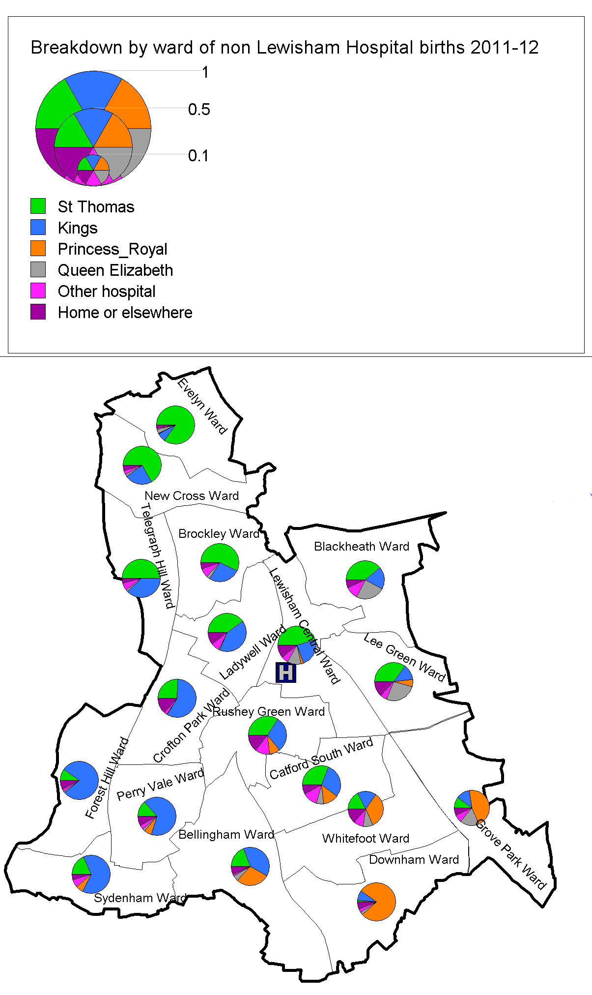

Fig 4

It is argued that the most likely outcome of closing the delivery units at Lewisham is that similar patterns of patient flow as occur at present would be found.

Predicted Numbers of Birth by Provider

On this basis, ie that women in Lewisham are likely to make the same sort of choice of alternative provider as they did in 2011-12, we can expect that if Lewisham’s delivery units close, the greatest proportion of births would occur at St Thomas’s, followed closely by King’s College Hospital, with only 4.4% of births occurring at QEH. (Table 4), giving rise to large numbers of extra births at these first two hospitals (Table 5). Numbers of total births at St Thomas’s would require consideration of the need for a double obstetric rota, and there would be almost 7,000 births at King’s (Table 6), assuming a constant number of births at these units to women from outside of Lewisham. Total births at St Thomas’s Hospital can be expected to be over 8000 per annum to at least the end of the decade

Table 4 Predicted dispersal of births to Lewisham Women
St Thomas's Hospital | 38.3%
King's College Hospital | 34.6%
Princess Royal University Hospital | 9.1%
Queen Elizabeth Hospital | 4.4%
Other hospital | 7.1%
Home /elsewhere | 6.4%
Total | 100%

Table 5 Number of increased births at each provider as a result of dispersal of births of Lewisham women
Increase | 2012 | 2013 | 2014 | 2015 | 2016 | 2017 | 2018 | 2019 | 2020 | 2021
St Thomas's Hospital | 1249 | 1266 | 1271 | 1267 | 1262 | 1253 | 1243 | 1235 | 1231 | 1227
King's College Hospital | 1128 | 1143 | 1148 | 1144 | 1140 | 1132 | 1122 | 1115 | 1112 | 1108
Princess Royal University Hospital | 298 | 302 | 303 | 302 | 301 | 299 | 296 | 295 | 294 | 293
Queen Elizabeth Hospital | 145 | 147 | 148 | 147 | 146 | 145 | 144 | 143 | 143 | 142
Other hospital | 230 | 233 | 234 | 234 | 233 | 231 | 229 | 228 | 227 | 226
Home /elsewhere | 209 | 211 | 212 | 212 | 211 | 209 | 207 | 206 | 206 | 205

Table 6 Projected numbers of births at SE London providers if births to Lewisham women are dispersed.
 |  | projected totals
 | total 2010-11 | 2014 | 2015 | 2020
St Thomas's Hospital | 6849 | 8120 | 8116 | 8080
King's College Hospital | 5835 | 6983 | 6979 | 6947
Princess Royal University Hospital | 4291 | 4594 | 4593 | 4585
Queen Elizabeth Hospital | 4266 | 4414 | 4413 | 4409

.Conclusion
The closure of the delivery units at Lewisham Hospital would result in large increases of numbers of births at St Thomas’s and King’s College Hospitals. These increases would require a double obstetric rota at St Thomas’s at a very early stage and for the foreseeable future. Lewisham women have, for years now, chosen these hospitals as their preference if they have decided not to have their baby delivered at Lewisham Hospital. There is no reason to believe that they will vary from this preference, or that they will move in large numbers to QEH, should the delivery units at Lewisham Hospital close. These changes will put intolerable pressure on St Thomas’s and King’s and will almost certainly require a double obstetric rota at St Thomas’s. This fact, together with all the other disadvantages of Option 1, means that this option for the future of maternity services for Lewisham women must be rejected.

Donal O’Sullivan
Pauline Cross
Meic Goodyear

12 December 2012

Source: ONS Public Health Births Files

