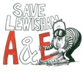
Hospital Workers’ Group

Campaign To Save Lewisham Hospital Continues…

Join our meeting to decide on practical action to save Lewisham Hospital. Everybody is welcome!

Meeting Point: Lewis Club, Lewisham Hospital, Lewisham High Street, SE13 6LH

Date & Time: Wednesday 13th February, 18:00 – 20:00

Buses: 47, 54, 75, 136, 185, 199, 208 Lewisham Hospital stop

Facebook:

http://www.facebook.com/lewishamkonp http://www.facebook.com/savelewishamhospitalnhs

Twitter:
http://www.twitter.com/lewishamkonp http://www.twitter.com/savelewishamae

Email:
lewishamhospitalworkers@gmail.com

Phone Anita on:
07775 871729
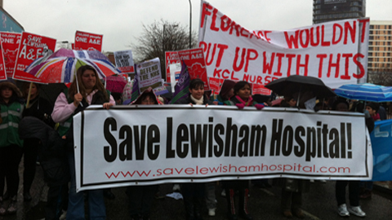

Called by Hospital Workers’ Group
www.savelewishamhospital.com

