Councillor Paul Bell: Answers to questions from the Save Lewisham Hospital Campaign

Q1 | Your record  As you know Lewisham Hospital has been under threat for much of the last 10 years, saved by a campaign led by SLHC, and by the legal campaign led by the campaign and Lewisham Council.  However, frontline health and social care support services are being cut to the bone.  Q1: Please tell us about what you as an individual councillor have done to protect Lewisham Hospital and local health services since 2012.
A1 | I’ve been a councillor since 2010. I voted for and campaigned in the Labour Group of councillors for the Council judicial review. I’ve been part of the Save Lewisham Hospital Campaign, been on the marches and supported the NHS in my politics. I’ve been on the Student Bursaries demonstration.  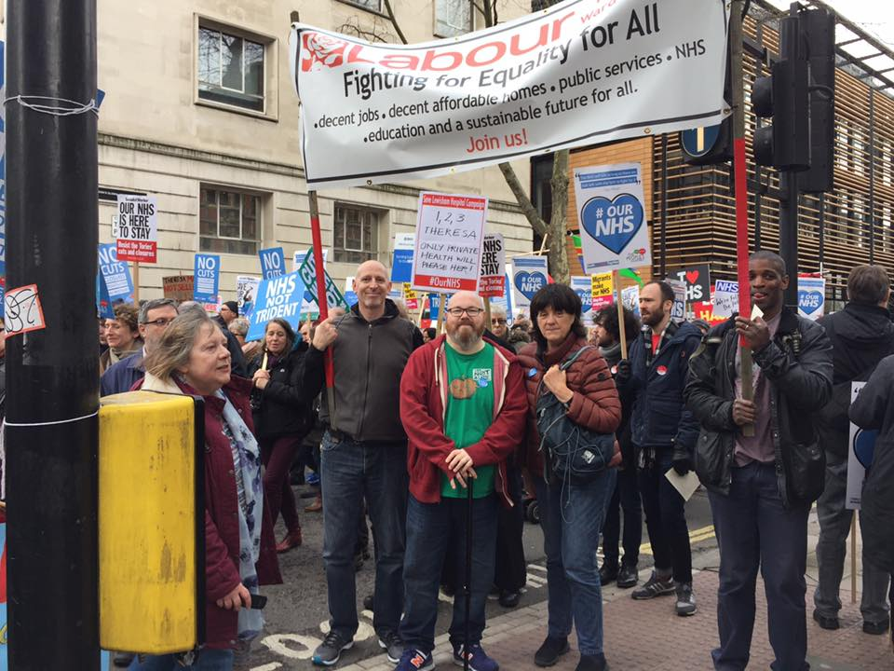  I’ve tried to protect public health budgets and resisted any attempts for them to be devolved to local authorities. I campaigned against the Health & Social Care Bill before it became an Act. I joined Keep Our NHS Public and the Socialist Health Association. I sit on the Healthier Communities Select Committee. I hold Lewisham CCG and NHS England to account and others to make sure as a Council we protect NHS services. I’ve campaigned against Greenwich CCG awarding the MSK contract to Circle.  Within the Labour Party nationally and locally, I’ve campaigned for – and will continue to campaign for – the NHS Reinstatement Bill.  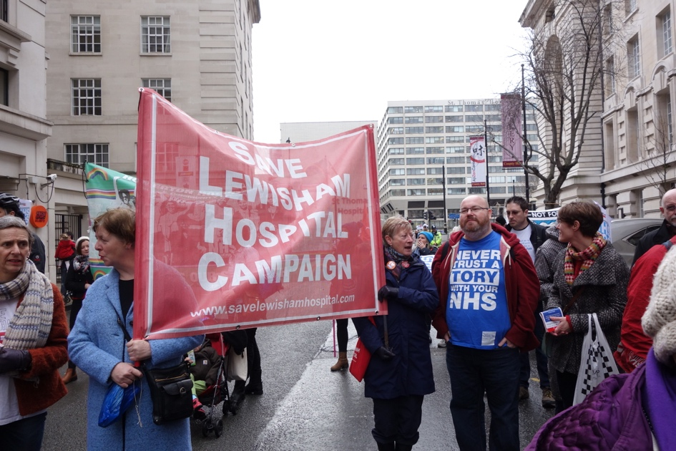
Q2 | Sustainability and Transformation Plans  Nationally and locally, although STPs may contain some positive ideas in theory, these ideas are mostly unachievable window-dressing in practice  The STPs have become the vehicle for driving through huge government/NHS England financial underfunding. By 2020/21 there will be a £1bn short fall annually in SE London’s budget for health care. These cuts are in the context of already savage LA cuts from central government.  (Plans include, as we hope you know, putting in post a single accountable officer to make decisions across the six CCGs of SE London. In many areas, CCGs are merging and the dialogue between a CCG its local LA will be distant and unequal.)  Q2: How will you use your local authority powers and elected status to ensure that the OHSEL STP, accountable care systems and implementation of related plans do not undermine local democratic overview of health and social care in Lewisham and lead to a worsening of care for the population?
A2 | I will as Mayor do the following:  - Use all available powers to stop the STPs from further rationing and cuts, stop Accountable Care Organisations from developing, work with the Lewisham CCG, surrounding CCGs and Health & Wellbeing Boards as well as NHS England from privatising and cutting NHS services. I believe in NHS providers and the NHS.  - The whole Council will be told that we oppose and will fight against privatisation, that the Health & Social Care Act needs to be repealed and that Lewisham is for the NHS Reinstatement Bill. This message will also be communicated to our MPs.  - Lewisham will also be leading the way in London to expose and campaign against any form of NHS privatisation. My experience in the USA with insurance based ACOs will be shared with fellow Labour leaders.  - Lewisham will constantly expose and resist lies and “sugar-coating” difficult decisions.  - Lewisham will not let the third sector undermine the NHS.  - Lewisham will work with partnerships with KONP and other organisations.  - Lewisham will use the media and a programme of education along with activism to defend the NHS.  - Lewisham will sign-up to UNISON’s Ethical Care Charter and start to manipulate the market provision of social care, joining-up with NHS partners.

Q3 | Local Authority Cuts  Central government has driven massive cuts to LA and NHS budgets. It transferred public health (PH) services to Lewisham in Autumn 2015, removing PH from the national NHS-reported funding plan and has immediately gone on to cut PH funding massively.  Lewisham & Greenwich NHS Trust and the LA had planned to cooperate on use of estate for the common good. Now the Naylor Review recommendations threaten sale of NHS estate locally and nationally which could remove options for cooperation between the local trust and the LA unless safeguards are underwritten.  Q3: How would you mitigate cuts already approved in the Public Health Budget and how would you deal with further pressures to sell NHS estate and make service cuts?
A3 | As Mayor, I will:  - Start to stabilise the Council finances. Unless the Government ease or abandon austerity in November, the Council will have to find between £43m to £72m just to stand still by 2020. There can be no promises on reversing cuts until we address the income deficit. We need to be bold and integrate public bodies together. In addition, we need to understand where the cost pressures can be alleviated by working as a “one-service” approach. For example, the council needs to do more on allowing people to stay in their homes. Splitting-up couples who’ve spent a lifetime together is truly awful, when one has to go in residential care.  - Instigate a “surplus-sharing” strategy with NHS partners, Goldsmiths and the council. We can use our own companies to provide services with each other, e.g. catering, cleaning and facilities management. Increasing productivity means paying decent terms and conditions. Removing the profit and cost cutting mentality from public services will lead to surpluses we can invest in services.  - Politically resist any attempts to sell NHS land and estates. As I said above, naming and shaming, campaigning and activism will be used to protect the NHS.  - Campaign for government to allow all councils in England to use the business rate surplus to fund social care.
Q4A | Privatisation  Privatising and outsourcing NHS and LA services are political choices, proven to be extremely expensive and controversial. Lewisham & Greenwich Trust (LGT) was underfunded by £36m in 2016/17 and was technically ‘in debt’ to that amount. Private contracts such as Circle musculoskeletal contract in Greenwich in 2016, threaten to encroach on and destabilise further LGT’s financial stability and threaten partnership delivery with Social Care.  Q4: What will your approach be towards bringing back into public service important aspects of social care and keeping health services in the public domain?
A4A | As Mayor, I will:  - End privatisation and outsourcing.  - Begin bringing services back in-house.  - Sign-up to UNISON’s Ethical Care Charter.  - Build relationships with commissioners and advise of Lewisham’s view.  - Review all care contracts.  - Bring in APSE to advise on how we can rebalance service provision to in-house against privatisation.  - I will fight against Public Service Mutuals.
Q5 | Queen Elizabeth Hospital’s PFI costs to LGT are approximately £35m in 2017/18 (a year’s payment of £18.7m after a subsidy of £16m from Dept of Health). This rises shockingly to £61.3m at end in 2029-30 (a year’s payment of £39.2m after subsidy).  Private finance initiatives are wasteful, expensive loans yet public sector borrowing has rarely been cheaper.  Q5: Can you see any way to work with NHS partners to minimise the damage of local PFI repayments?
A5 | As Mayor, I will  - Look at ways of ending PFI contracts early with other public providers if it will save money in the medium to long term.  - Build relationships with the NHS to work co-operatively, collectively and together to put our residents first.  - Review all PFI contracts in the Council. I don’t believe in PFI. We can borrow much cheaper from the Public Works Loan Board.  - Work in partnership with the Save Lewisham Hospital Campaign over the NHS.

